Step 1: DECIDING (NOT) TO SEGMENT:

It is crucial to comprehend the ramifications of pursuing a market segmentation strategy before

devoting time and resources to a market segmentation analysis. The main takeaway is that the

organisation must make a long-term commitment to the segmentation strategy.

Potentially required changes are:

1. Development of new products.

2. Modification of existing products.

3. Changes in pricing and distribution channels.

The decision to study the possibility of a market segmentation strategy must be made at the

highest executive level and must be consistently conveyed to and reinforced across all

organisational levels due to the significant consequences of such a long-term organisational

commitment.

Implementation Barriers:

First group of barriers related to the market segmentation

• Lack of leadership,

• pro-active championing,

• commitment, and involvement in the market segmentation process by senior leadership

undermines the success of market segmentation.

Second group and other barriers related to the market segmentation.

• Lack of training.

• Lack of a formal marketing function or atleast a qualified marketing expert in the

organization.

• Lack of a qualified data manager and analyst in the organization.

• Lack of financial resources.

• Lack of planning or bad planning.

• Lack of structured processes.

• Lack of time to conduct the market segmentation analysis without time pressure.

Step 2: SPECIFYING THE IDEAL TARGET SEGMENT

Knock-out criteria:

If market segments identified by the market segmentation analysis meet the requirements to

be evaluated using segment attractiveness criteria, the segments are knocked out.

• The segment must be uniform; its participants must be comparable to one another.

• The segment must be distinct, and its members must be clearly distinguishable from those

of other segments.

• For it to be worthwhile to invest extra money tailoring the marketing mix for them, the

segment must be big enough and contain enough people.

• The segment must complement the organization's strengths, and the organisation must be

able to meet the needs of segment participants.

• The segment's participants must be recognisable and visible in the marketplace.

• To make the segment accessible to them with the customised marketing mix, the segment

must be approachable; members of the segment must be contactable.

Attractiveness Criteria:

The definitions of attractiveness are not absolutes. Segments are not evaluated as meeting

or not meeting beauty criteria. Each market segment is instead given a rating; depending

on a particular criterion, it may be more or less attractive. In Step 8 of the market

segmentation study, a market segment is chosen as a target segment based on its

attractiveness across all criteria.

Implementing a Structured Process

The segmentation literature generally agrees that it is advantageous to use a structured

procedure when evaluating market segments. Examine each of the relevant factors for

determining a market segment's attractiveness. Together, the segmentation team members

should decide on a subset of no more than six criteria after discussing the criteria. Each

segment attractiveness criterion should receive 100 points, as determined by the segmentation

team. Distribute them such that each beauty criterion is given weights that represent their

relative relevance. Decide on a weighting after discussing weightings with the other

segmentation team members. Present the advisory committee with the chosen segment

attractiveness criteria and the proposed weights allocated to each of them for debate and (if

necessary) revision.

STEP 3: COLLECTING DATA

3.1 Segmentation Variables: This term refers to a single measured value, such as a single

response in a survey or a single observed category of spending. The phrase "segmentation

criterion" refers to the type of data that is utilised to segment the market. Common sense and

data-driven market segmentation vary in that the latter is based on numerous segmentation

variables as opposed to just one.

3.2 Segmentation criteria: Here, the phrase "segmentation criterion" is used more broadly than

"Segmentation variable." The phrase "segmentation criterion" refers to the type of data that is

utilised to segment the market. It may also be related to a single concept, like advantages

desired.

3.2.1 Geographical segmentation: When using geographic segmentation, the only factor

employed to create market segments is the consumer's place of residence. Although

straightforward, the geographic segmentation strategy is frequently the most suitable. Each

consumer may be quickly assigned to a geographic unit, which is the main benefit of geographic

segmentation.

3.2.2 Socio- Demographic Segmentation: Age, gender, income, and education are among the

segmentation variables used. The benefit of using socio-demographic segmentation criteria is

that it is simple to determine which section each consumer belongs to.

3.2.3 Psychographic Segmentation: Due to the difficulty in identifying a single trait in an

individual that would give insight into the psychographic dimension of interest, psychographic

criteria are inherently more complex than geographic or sociodemographic criteria.

3.2.4 Behavioural Segmentation: A wide range of possible behaviours can be used for this

purpose, including prior experience with the product, frequency of purchase, amount spent on

purchasing the product on each occasion (or across multiple purchase occasions), and

information search behaviour. The key advantage of behavioural approaches is that, if based on

actual behaviour rather than stated behaviour or stated intended behaviour, the very

behaviour of interest is used as the basis of segment extraction.

3.3 Data from Survey Studies: Most market segmentation analyses are based on survey data.

survey data – as opposed to data obtained from observing actual behaviour can be

contaminated by a wide range of biases.

3.3.1 Choice of Variables: All variables relevant to the construct captured by the segmentation

criterion need to be included.

3.3.2 Response Options: Answer options provided to respondents in surveys determine the

scale of the data available for subsequent analyses. Options allowing respondents to answer in

only one of two ways, generate binary or dichotomous data. Such responses can be

represented in a data set by 0s and 1s.

3.3.3 Response Styles: A response bias is a systematic tendency to respond to a range of

questionnaire items on some basis other than the specific item content (i.e., what the items

were designed to measure). Response styles affect segmentation results because commonly

used segment extraction algorithms cannot differentiate between a data entry reflecting the

respondent’s belief from a data entry reflecting both a respondent’s belief and a response style.

3.3.4 Sample Size: - It is the act of choosing the number of observations or replicates to include

in a statistical sample. The sample size is an important feature of any empirical study in which

the goal is

to make inferences about a population from a sample. In practice, the sample size used in a

study is usually determined based on the cost, time, or convenience of collecting the data, and

the need for it to offer sufficient statistical power.

3.4 Data from Internet Source: Increasingly organisations have access to substantial amounts

of internal data that can be harvested for the purpose of market segmentation analysis. .

Typical examples are scanner data available to grocery stores, booking data available through

airline loyalty programs, and online purchase data.

3.5 Data from Experimental Studies: The data that can form the basis of market segmentation

analysis is experimental data. Experimental data can result from field or laboratory

experiments. Experimental data can also result from choice experiments or conjoint analyses.

The aim of such studies is to present consumers with carefully developed stimuli consisting of

specific levels of specific product attributes.

Step 6: Profiling Segments

Identifying Key Characteristics of Market Segments

The aim of the profiling step is to get to know the market segments resulting from

the extraction steps. Profiling is only required when data-driven market segmentation

is used. For common-sense segmentation, the profiles of the segments are predefined.

If, for example, age is used as the segmentation variable for the common-sense

segmentation, it is obvious that the resulting segments will be age groups. At the profiling

stage, we inspect a number of alternative market segmentation

solutions. This is particularly important if no natural segments exist in the data,

and either a reproducible or a constructive market segmentation approach has to be

taken.

Traditional Approaches to Profiling Market Segments

Data-driven segmentation solutions are usually presented to users (clients,

managers) in one of two ways: (1) as high-level summaries simplifying segment

characteristics to a point where they are misleadingly trivial, or (2) as large tables

that provide, for each segment, exact percentages for each segmentation variable.

Such tables are hard to interpret, and it is virtually impossible to get a quick

overview of the key insights.

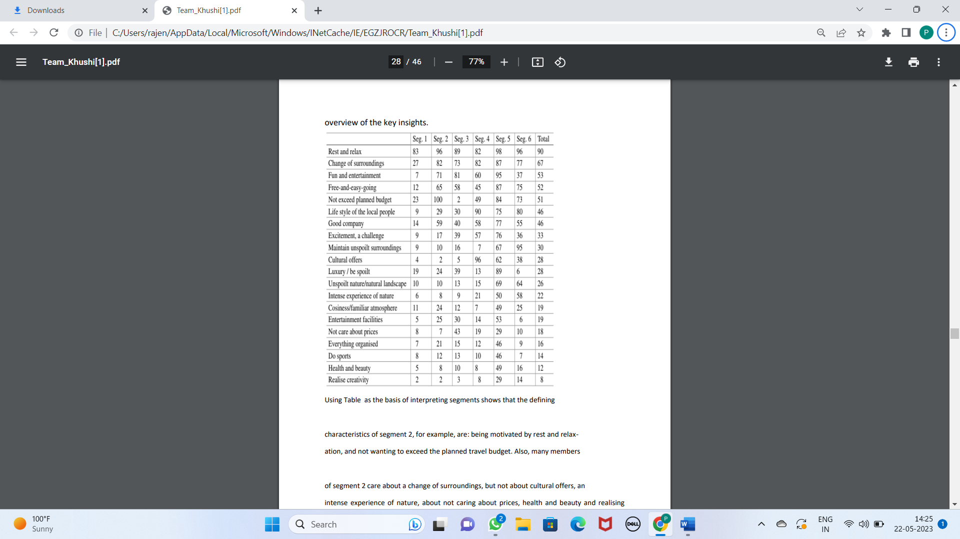

Using Table as the basis of interpreting segments shows that the defining

characteristics of segment 2, for example, are: being motivated by rest and relaxation, and not wanting to exceed the planned travel budget. Also, many members

of segment 2 care about a change of surroundings, but not about cultural offers, an

intense experience of nature, about not caring about prices, health and beauty and realising

creativity. Segment 1 is likely to be a response style segment because –

for each travel motive – the percentage of segment members indicating that a travel

motive is relevant to them is low (compared to the overall percentage of agreement).

Sometimes – to deal with the size of this task – information is provided about

the statistical significance of the difference between segments for each of the

segmentation variables. This approach, however, is not statistically correct. Segment

membership is directly derived from the segmentation variables, and segments are

created in a way that makes them maximally different, thus not allowing to use

standard statistical tests to assess the significance of differences.

Segment Profiling with Visualisations

Neither the highly simplified, nor the very complex tabular representation typically used to

present market segmentation solutions make much use of graphics, although data visualisation

using graphics is an integral part of statistical data analysis Graphics are particularly important in

exploratory statistical analysis (like cluster analysis) because they provide insights into the complex

relationships between variables. In addition, in times of big and increasingly bigger

data, visualisation offers a simple way of monitoring developments over time.

Visualisations are useful in the data-driven market segmentation process to

inspect, for each segmentation solution, one or more segments in detail. Statistical

graphs facilitate the interpretation of segment profiles. They also make it easier to assess the

usefulness of a market segmentation solution. The process of segmenting

data always leads to a large number of alternative solutions. Selecting one of the

possible solutions is a critical decision. Visualisations of solutions assist the data

analyst and user with this task.

Identifying Defining Characteristics of Market Segments

A good way to understand the defining characteristics of each segment is to produce

a segment profile plot. The segment profile plot shows – for all segmentation

variables – how each market segment differs from the overall sample. The segment

profile plot is the direct visual translation of tables such as Table 8.1. The t() around the data

matrix vacmot transposes the matrix such that distances

between columns rather than rows are computed. Next, hierarchical clustering of

the variables is conducted using Ward’s method. Figure 8.1 shows the result. Argument which

specifies the variables to be included, and their order of presentation. Here, all variables are shown in the order suggested by hierarchical clustering

of variables. shade = TRUE identifies so-called marker variables and depicts

them in colour. These variables are particularly characteristic for a segment. All

other variables are greyed out. To make the chart even easier to interpret, marker variables

appear in colour

(solid bars). The remaining segmentation variables are greyed out. The definition

of marker variables in the segment profile plot used by default in barchart()

is suitable for binary variables, and takes into account the absolute and relative

difference of the segment mean to the total mean. Marker variables are defined as

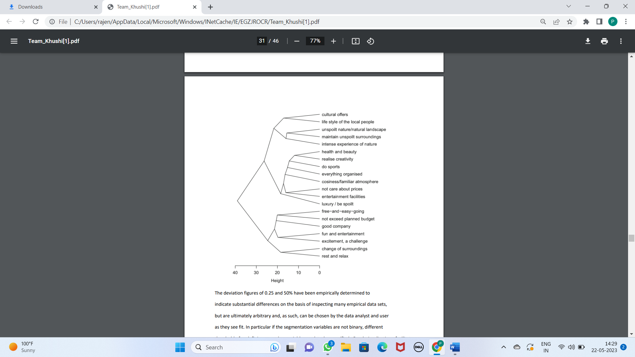variables which deviate by more than 0.25 from the overall mean.

The deviation figures of 0.25 and 50% have been empirically determined to

indicate substantial differences on the basis of inspecting many empirical data sets,

but are ultimately arbitrary and, as such, can be chosen by the data analyst and user

as they see fit. In particular if the segmentation variables are not binary, different

thresholds for defining a marker variable need to be specified. Good visualisations facilitate

interpretation by

managers who make long-term strategic decisions based on segmentation results.

Such long-term strategic decisions imply substantial financial commitments to the

implementation of a segmentation strategy. Good visualisations, therefore, offer an

excellent return on investment.